1. Create a remote repository and clone it.

Login gitlab web page and then click the “New project” button

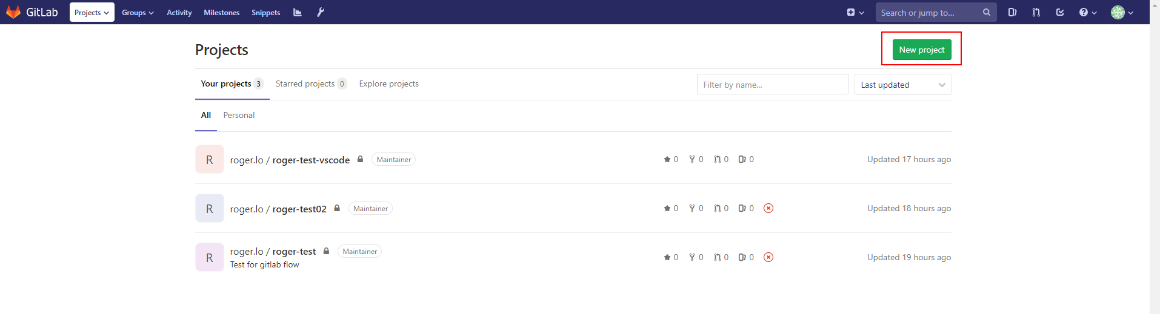

Type the name & description, choose visibility level, check the last item to auto make a readme file.

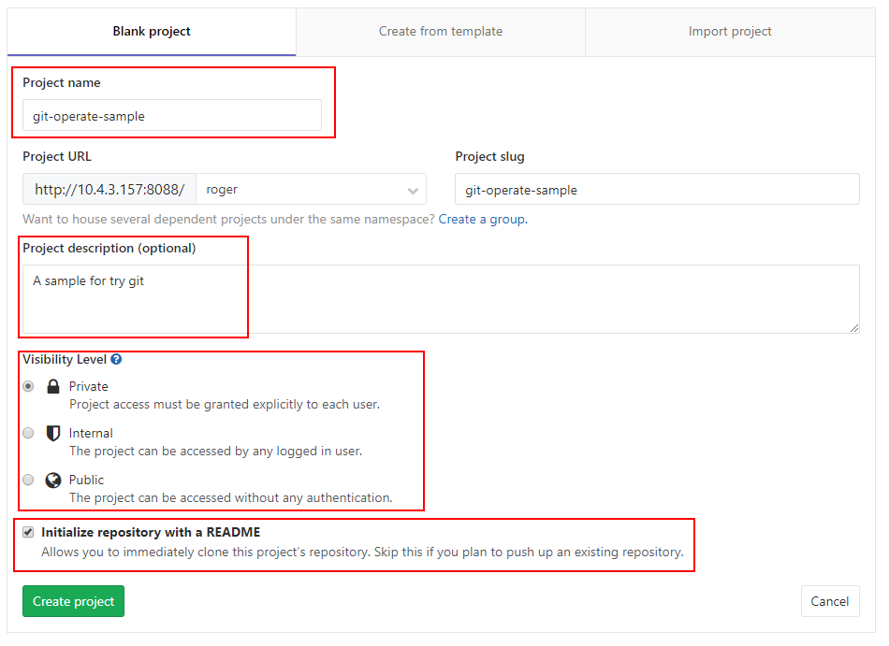

Get the clone URL

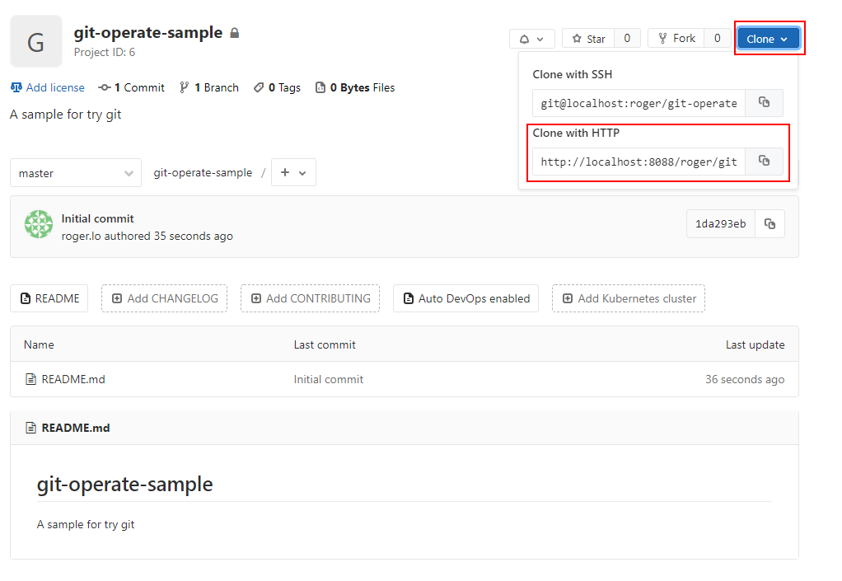

Clone this project to your PC by this command

git clone http://10.4.3.157:8088/roger/git-operate-sample.git git-operate-sample

It should be:

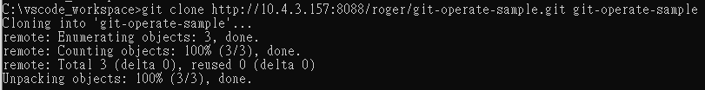

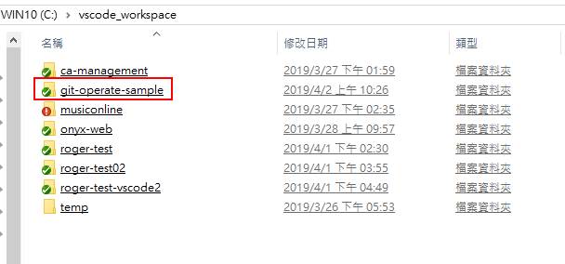

1. Basic operation

Get this folder status of git

git status

Normal case:

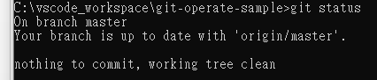

If something change:

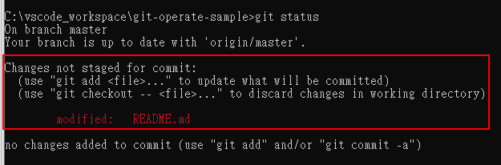

After modify something, we have to add the modified file to temp stage first

git add

It should be:

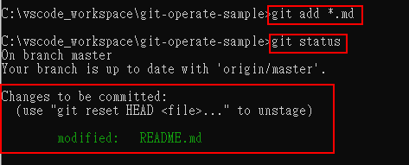

The next step, we have to commit it to local repository, use “-m” to type commit message.

git commit -m

It should be:

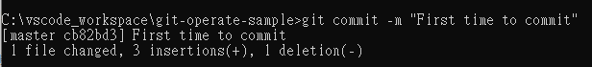

Now, we can push this commit to remote repository

git push

It should be:

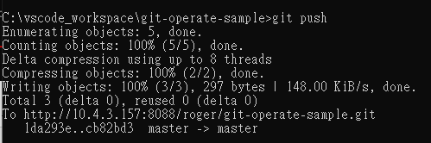

And you can see the graph at gitlab web page

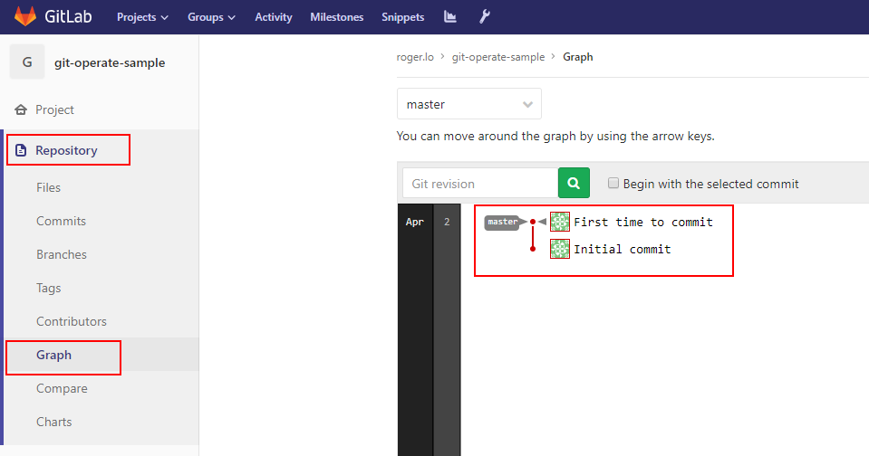

If we want to get the last version from remote repository

git pull –-no-ff

Use “—no-ff” to make a merge commit node.

It should be:

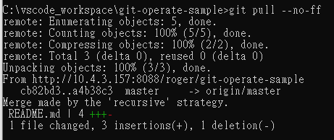

If we want to get log for local repository

git log --oneline

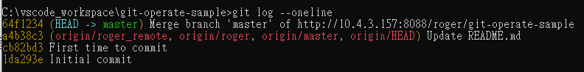

1. Branch

Get the branch status

git branch

It should be:



Create branch on remote at gitlab web page

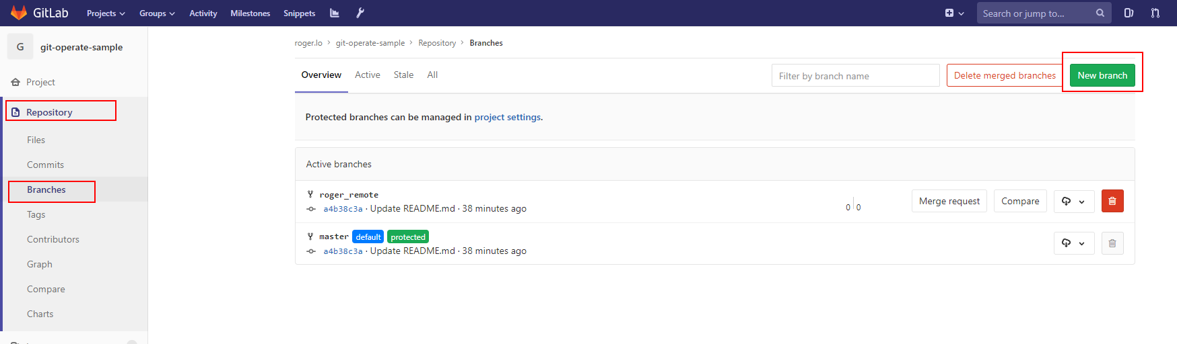

Update the remote branch for local by “git pull” and checkout the branch

git checkout

It should be:

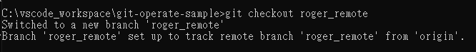

Now, we should have two branch:



Create local branch by “git branch”

If only “git branch”, this command can get branch status.

If append a branch name, this command will create a new branch.

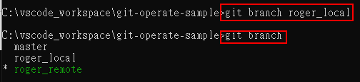

Checkout the new branch, it should be:

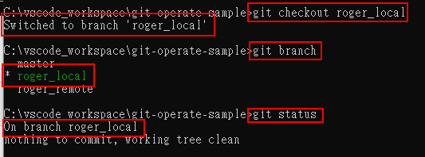

1. Merge

Use command to merge other branch,

git merge –-no-ff

Use “—no-ff” to make a merge commit node.

It should be:

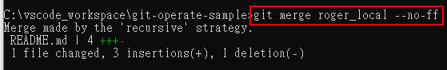

The git log:

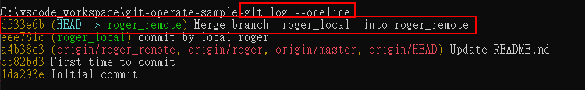

1. Solve conflict

If the source code has conflict when merge, it should be:

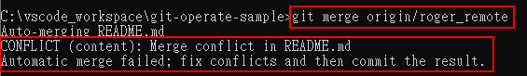

And the file content should be:

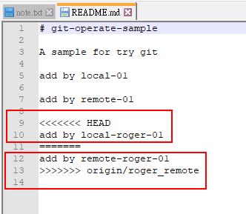

The git status should be:

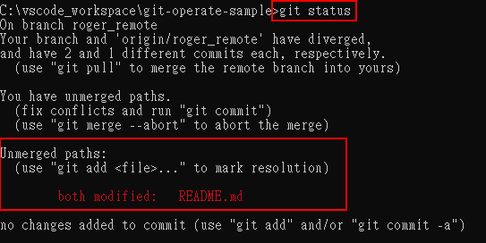

After we solve the conflict, just add the file to temp stage, and then the git status will change to:

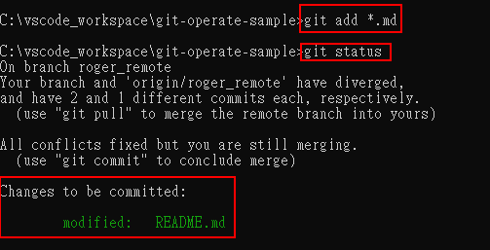

Finally, we can just commit & push, and you’ll see the graph at gitlab web page.

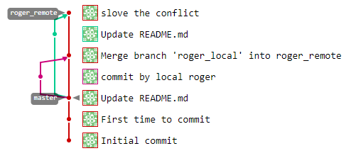

1. Rebase

We can also use “rebase” to merge two branch

git rebase

It should be:



And the git status & log will be:

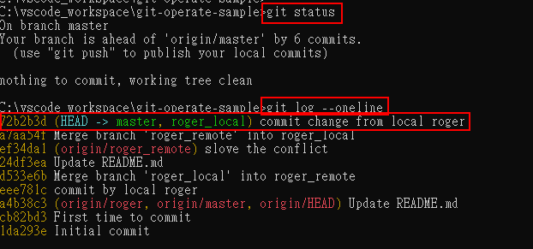

If we have conflict when rebase, it should be:

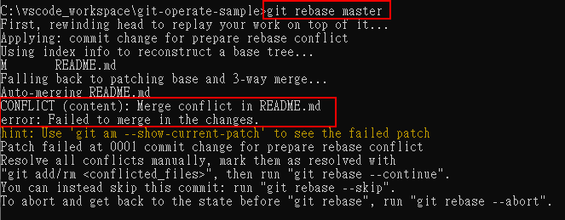

Now, the git status should be:

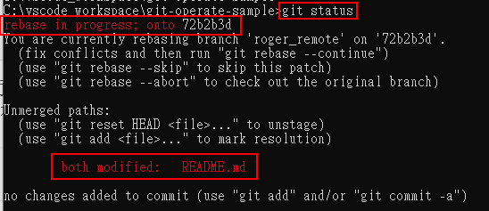

And the file content will be:

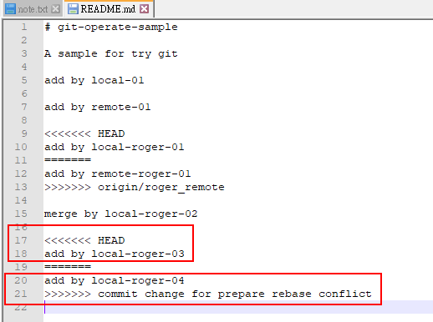

After we solve this conflict, we have to add this file to temp stage and continue the rebase flow.

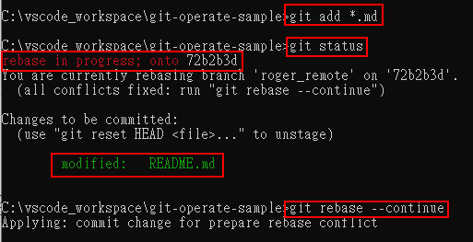

After we push to remote, the graph at gitlab web page should be:

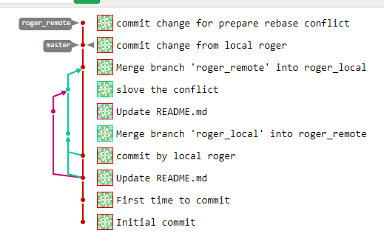

1. Chrry pick

If you like some commit of other branch, like this sample:

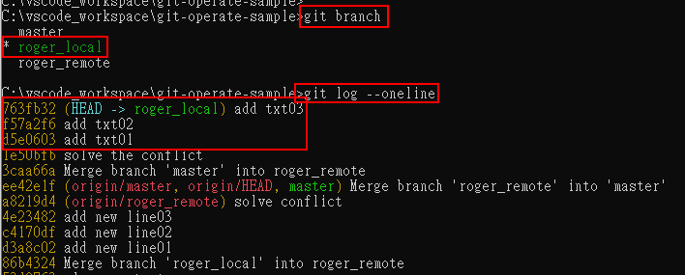

And you want to get the commit “add txt02” & “add txt03” to “roger_remote” branch

Checkout to the target branch, and then use this command

git cherry-pick

You need append the SHA-1 string of the commit that you want to this command like this sample:

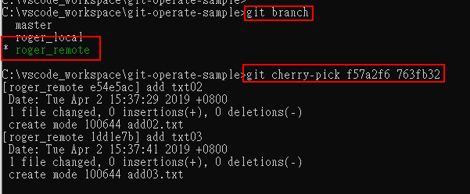

And the log will be:

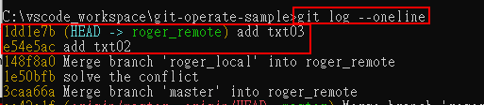

1. Merge request

When some branch will have more commit than branch “master” at remote repository.



For protected, we can’t merge into “master” branch directly.

We have to create a “merge request” to administrator of “master” branch first.

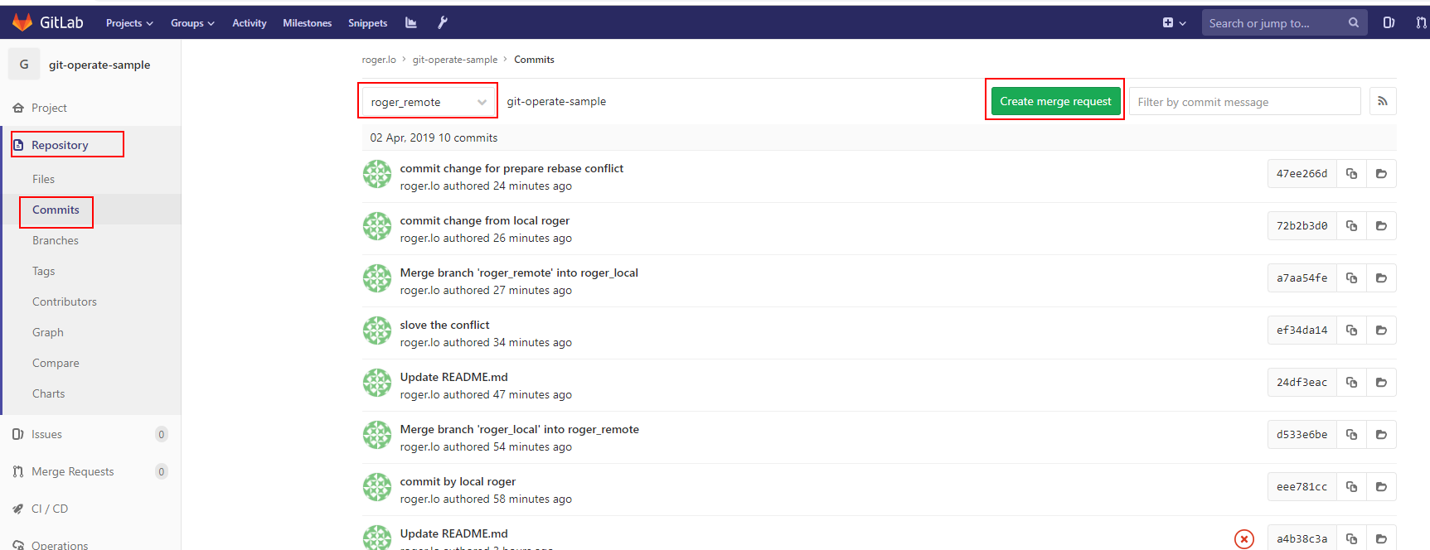

Fill out all information, and then submit

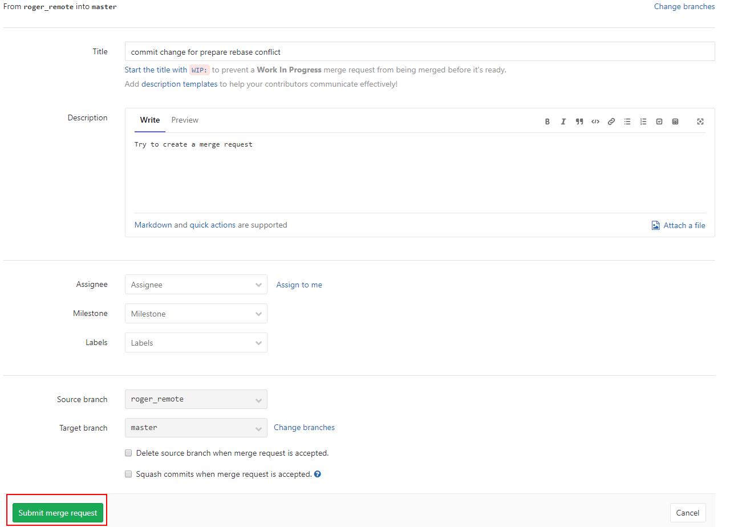

Administrator will see it:

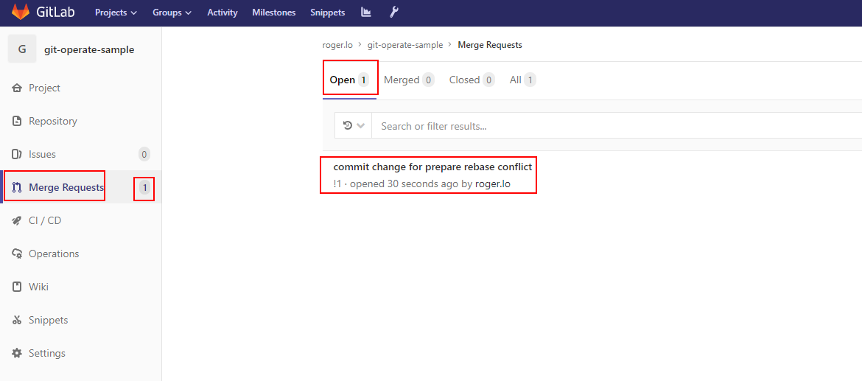

Administrator can write some comment and choose that close this request or merge it.

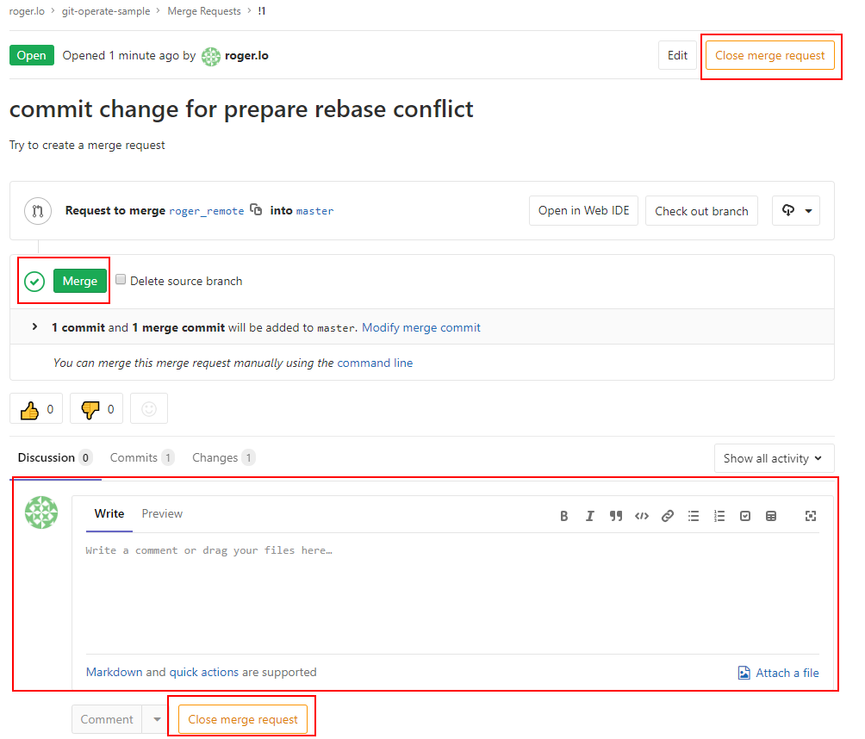

After administrator merge it, you’ll see the graph at gitlab web page:

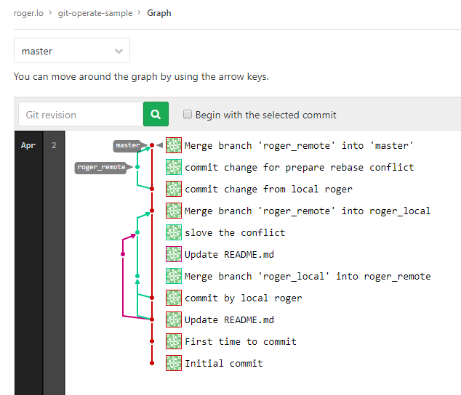

1. Create tag

Choose which commit you want to tag from graph at gitlab web page.

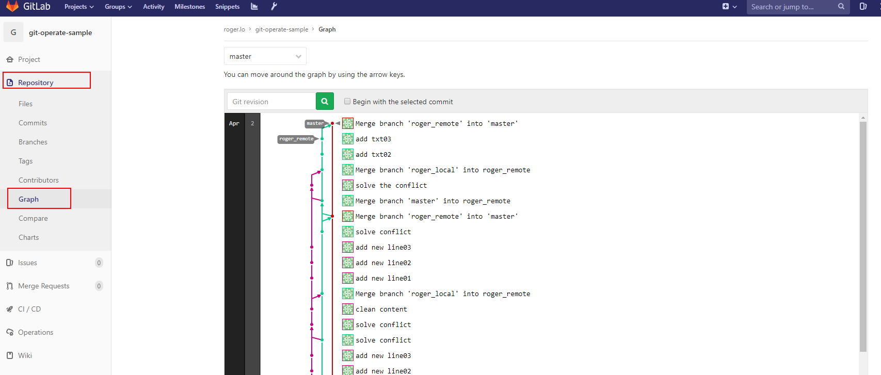

Just click the commit node and then click the “tag” button at commit page.

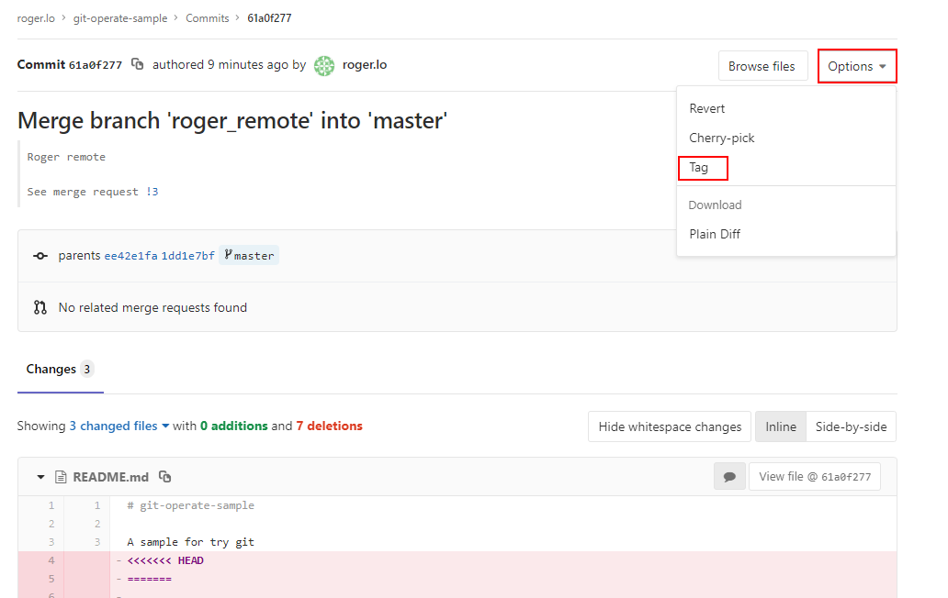

Fill out the tag information and create it

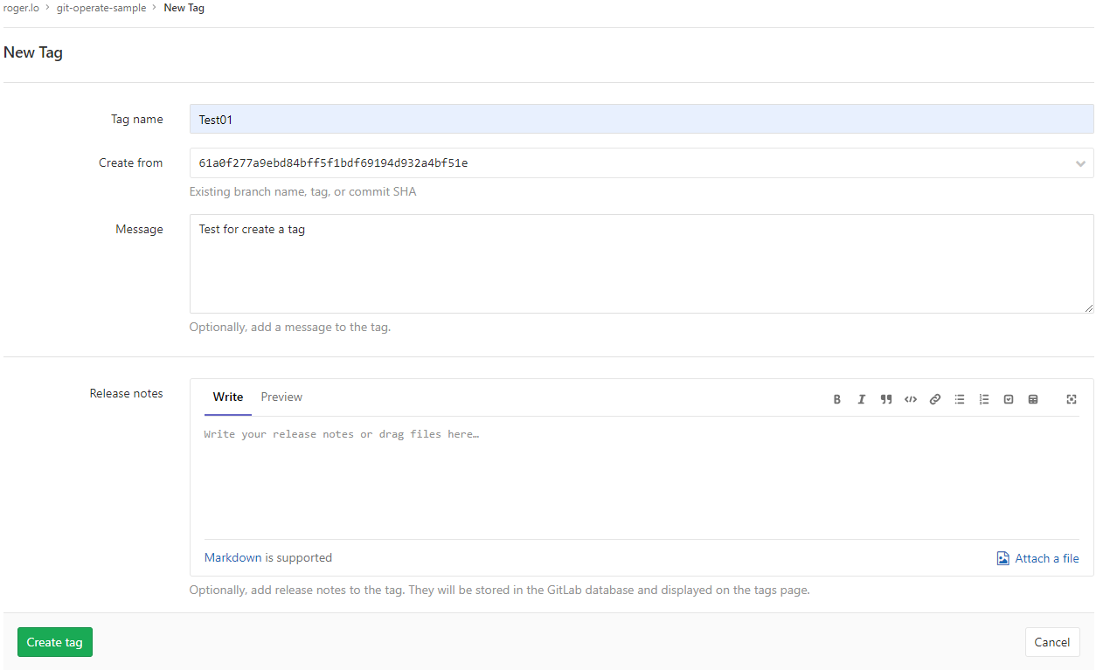

You’ll see the tag on the graph at gitlab web page.

